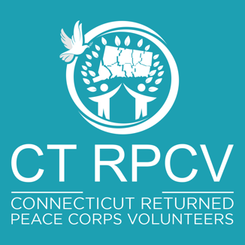

RETURNED PEACE CORPS VOLUNTEERS
OF CONNECTICUT (CTRPCV)
CTRPCV SERVICE FUND (CSF)
PROJECT GRANT APPLICATION

EVALUATION CRITERIA:

Priority will be given to applications as follows:

1. Applicants with whom CTRPCV members or currently serving PCVs from CT are personally involved, either through previous work or a current relationship;

2. Applications that include cash or in-kind matches, either from the proposed grantee or third-party sources (e.g., donations of goods, services, labor, facility, transportation, etc.);

3. Projects that contribute to the future sustainability of an organization, facility or business;

- Projects that address defined, recognizable needs and can produce measurable results.

- If the projects are domestic, grantees that are 501.c.3 organizations.

- Peace Corps Volunteers should also submit their Peace Corps Partnership Proposal in addition to completing the CTRPCV Service Fund grant application.

APPLICATION PROCESS:

- All applicants must submit a completed CTRPCV Service Fund Project Grant Application. All applications must be transmitted by a “nominating” CTRPCV member. Usually grants will be awarded in an amount of $1,000.00.

- If an application deadline is established for a particular period, applications must be submitted by that deadline established in order to be considered.

- Applications will be reviewed by a committee (the CTRPCV Service Fund Committee), which shall report to the CTRPCV Board of Directors. Awards will be made based on, but not limited to, the above criteria. Consideration will be given to overall project plan design.

AWARD AND REPORTING:

- Grant award checks will be made out only to the applicant organization and mailed or delivered to an approved recipient.

- As a condition of receiving the grant, within six (6) months of receipt of funds, the recipient shall submit a report (by mail or email) to the CTRPCV Service Fund Committee describing the use of the funds and the results therefrom, including photographs if possible. If a delay should occur in initiating the project or expending the funds, the recipients shall provide a brief interim report.

- All communications to CTRPCV should be addressed to:

Maureen Shanley
Attn: CTRPCV CSF
3828 Cheverly Drive W
Lakeland, FL 33813
H: 863-500-9146 or C: 203-788-0163
Email: grants@ctrpcv.org

CTRPCV SERVICE FUND GRANT APPLICATION

SECTION I – GENERAL INFORMATION
Date of Application: | Proposed Project Descriptive Title: |  | Amount of Funding Request:
Nominating CTRPCV Member: | Tel: | Cell: | Email Address:
Name & Address of Proposed Grantee: |  | Tel: | Fax:
Name & Title of Grantee Contact Person: |  | Tel: | Email Address:
Brief Description of Grantee Organization, Activities and Mission (If 501.c.3 organization, attach documentation):

SECTION II – PROJECT INFORMATION [Attach separate page if more space needed)
Project Start-Up Date: | Project Completion Date:
Summarize Goals of Project and Expected Results and Beneficiaries

Project Implementation Plan and Milestones

Budget: Provide details as to how project monies will be spent, including matching funds, if any (salaries, services, equipment, other); provide information on amount and source of matching funds

SECTION III – SIGNATURE
Nominating CTRPCV Member: | Signature: | Date:

Rev. 11/21/19

